

Electronic Services Portal (ESP) Website
Provider Registration

www.etimesheets.ihss.ca.gov




For assistance call the San Diego Public Authority Provider Enrollment and Training Department at
(866) 351-7722.

REGISTRATION AS A FIRST TIME USER

You will need the following information to register exactly as shown in your IHSS records:
- Your first name and last name
- 9-digit provider number
- Date of birth
- Last four digits of your social security number
- A valid e-mail address

To access the Electronic Services Portal Website, please visit www.etimesheets.ihss.ca.gov

There are 5 steps to the Registration process:

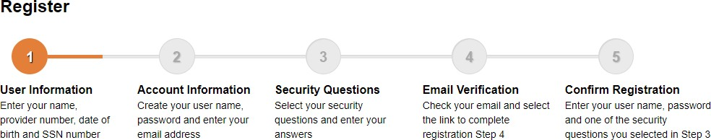

Note: Each step will start off orange, then turn green when completed.

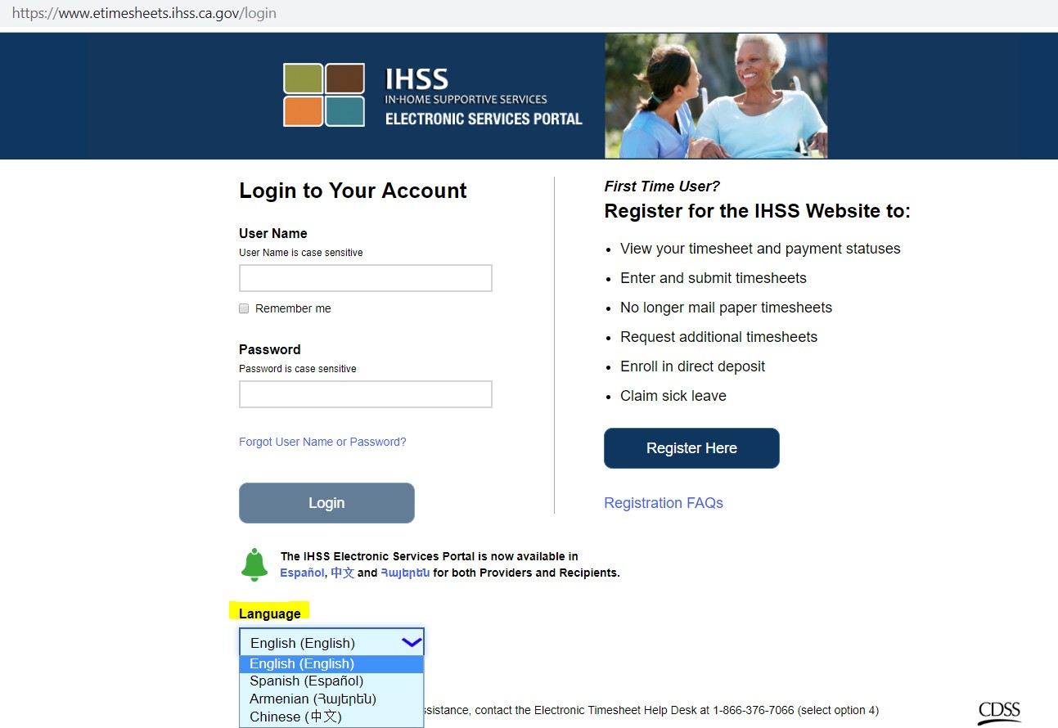

- Go to "Language."
- Click the drop-down menu.
- Select your preferred Language.
- Click the "Register Here" button.

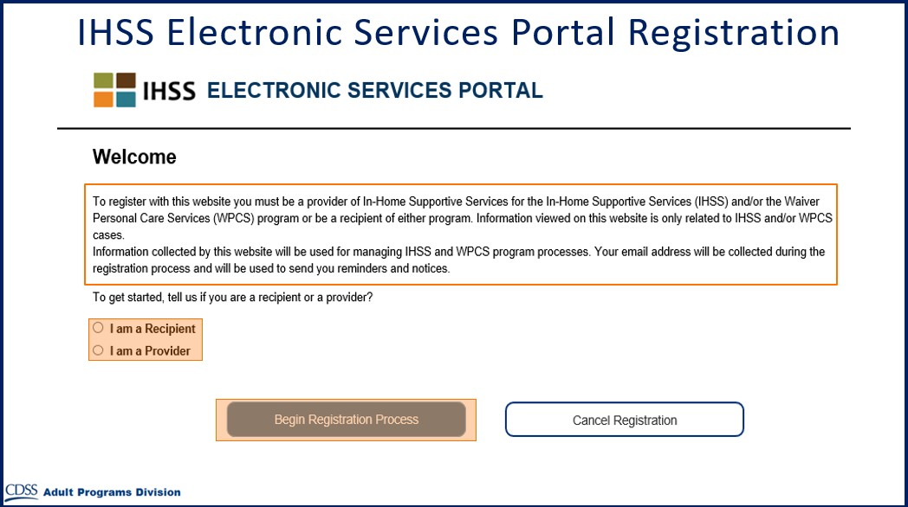
Now you'll see the Welcome screen.
- Click "I am a Provider."
- Click "Begin Registration Process."

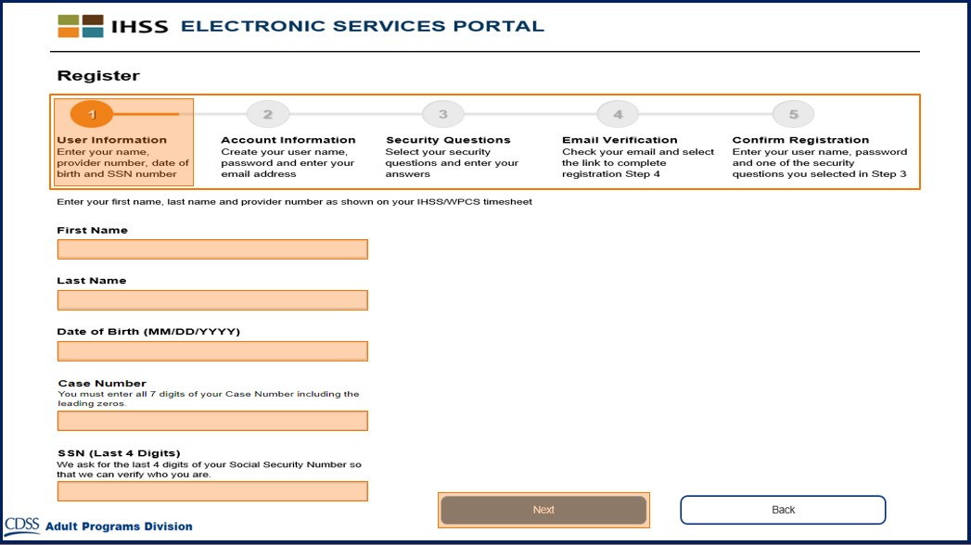
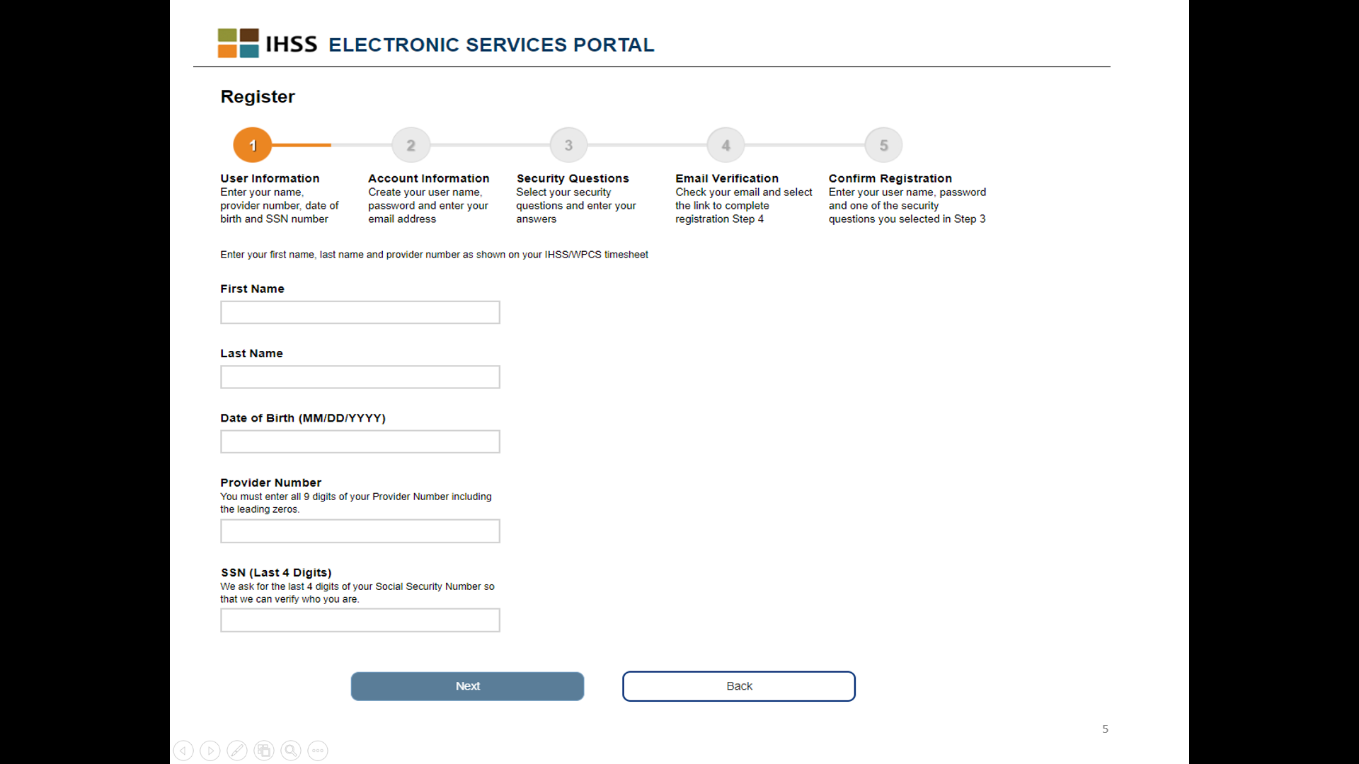
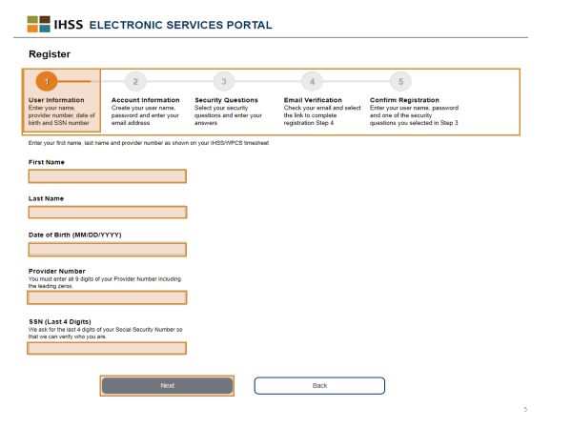
Step 1: User Information
Enter your information:
- First Name.
- Last Name.
- Date of Birth.
- Provider Number - It is a 9-digit number and is located on your paper timesheet, or a previous paystub.
- The Last Four Digits of your Social Security Number
Note: If you receive a message informing you that the information is not a match to our records, please contact San Diego Public Authority at (866) 351-7722.
- Click “Next.”

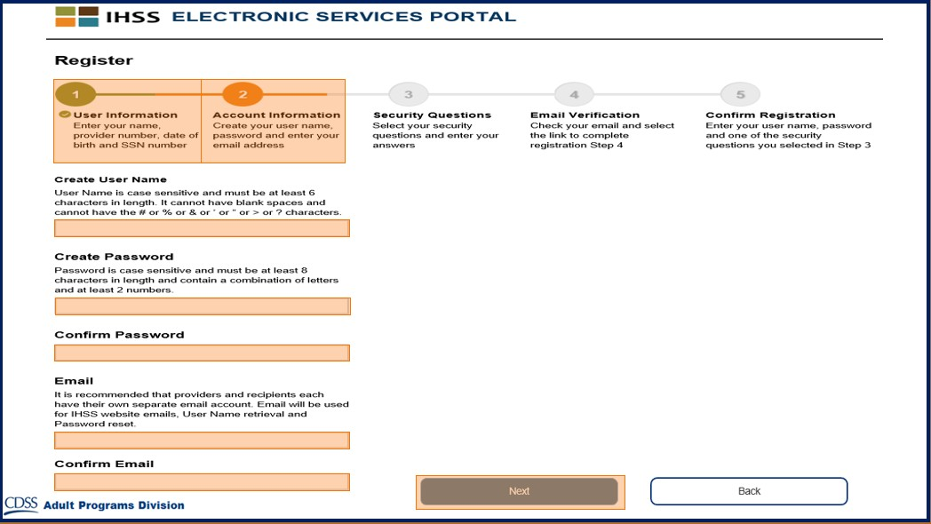

Step 2: Account Information
- Create User Name
- Your user name is case sensitive and can be anything you want it to be, it must be at least 6 characters, these can be numbers, letters, or symbols. These symbols cannot be used: # % & ’ > ?
- Create Password
- Your password is case sensitive and must be at least 8 characters in length, and must include a combination of letters, at least two numbers and no special characters.
- Confirm Password
- Enter the same password again
- Email:
- Enter a valid email address, as this will be used for notifications on your account
- Confirm Email
- Enter the same email again

- Click “Next.”

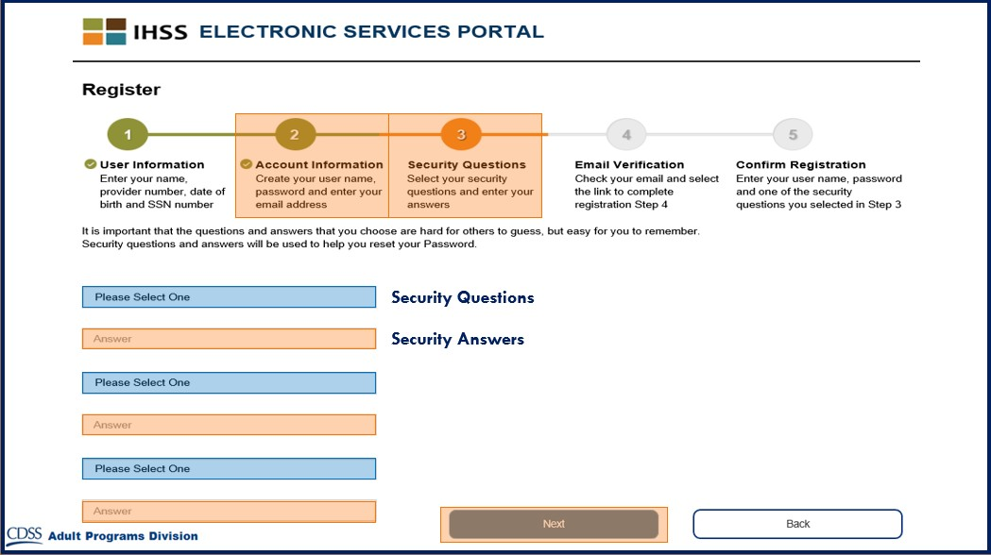

Step 3: Security Questions
- Choose three different security questions. Click the arrow on the right-hand side of the box to see the questions you can choose from. Select your questions then enter your answers.
- Click “Next.”

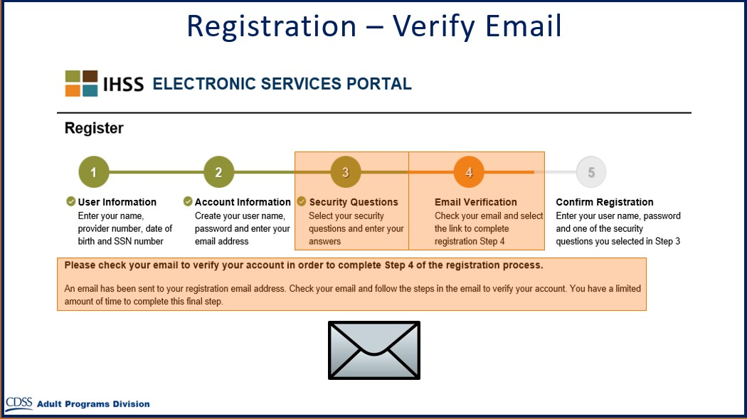

Step 4: Verify Email
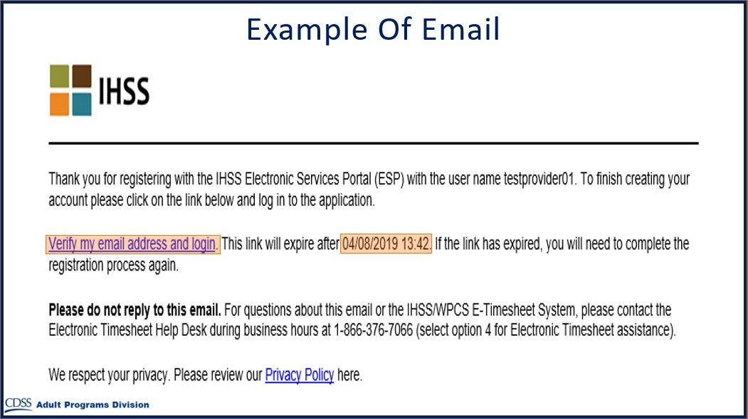
- Check your private email for a message from the IHSS Website.
Here is a sample of what your email message will look like.
- Open the email to verify your email address.
- Click on “Verify my email address and login” link.

- It is important to verify your email address immediately.
- If your email login link times out, you will need to begin the registration process again.
Note: If you could not find the email, check your spam or junk folders.

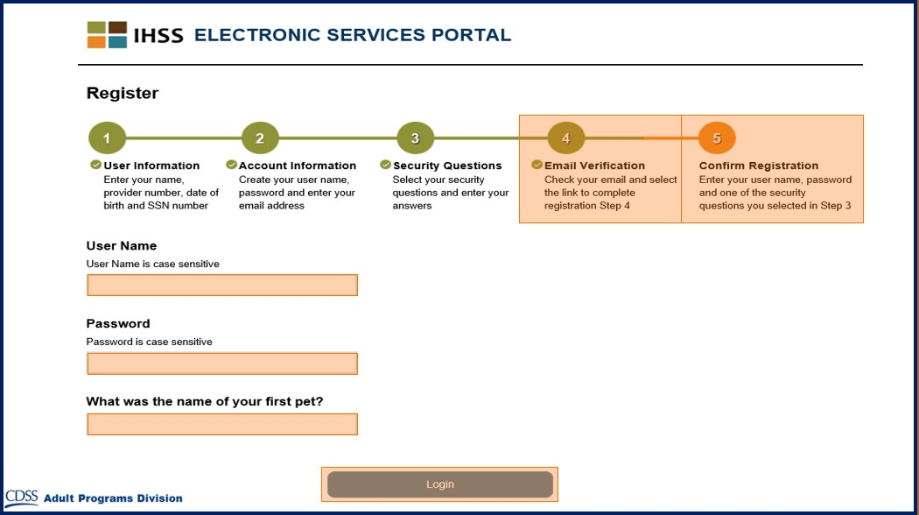
Step 5: Confirm Registration
- Enter your user name, password, and the answer to your security question.
- Click “Login.”

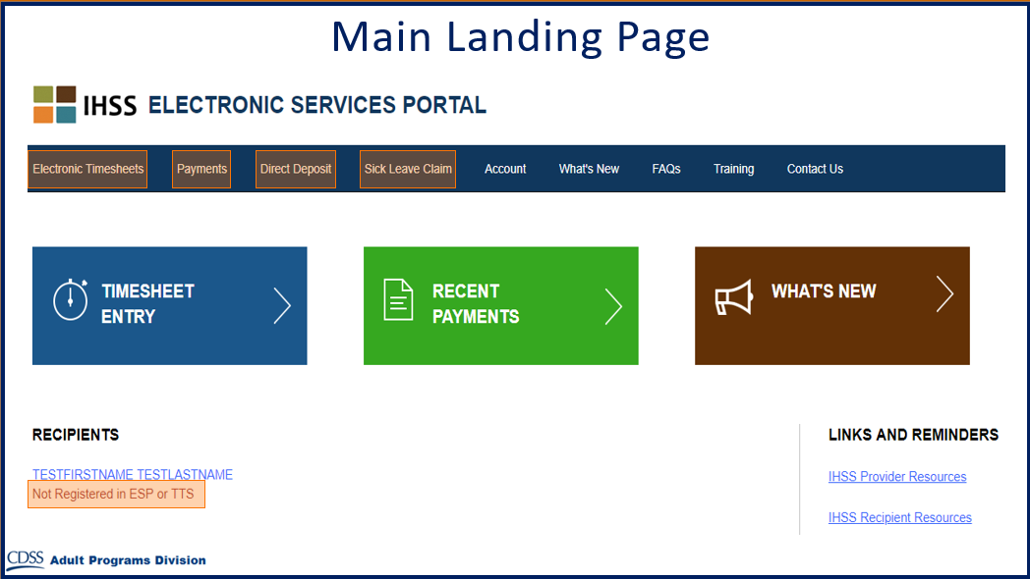

Main Landing Page
You can now do the following using your account:
- Enroll into Electronic Timesheets
- View Payment History
- Sign up for Direct Deposit online
- Submit a Sick Leave Claim online

